Git Strat

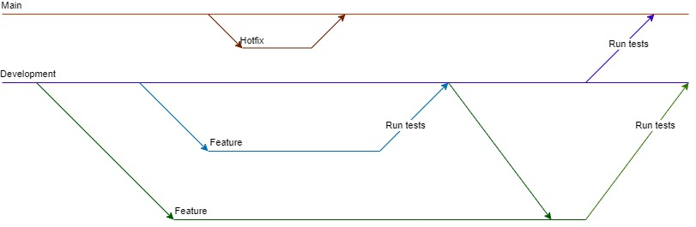

Main branch rules:

1. Only merge from hotfix and development, never commit.
2. Only merge from development at the end of a sprint.
   1. Before merging run all tests.

Development branch rules:

1. Only merge from feature branches, never commit.
   1. When merging run all tests.

Feature branch rules:

1. When the feature originates from a Jira Issue then create it via Jira
2. When committing to this branch use the Jira issue number in the commit message. For example, “NULL-69”.
3. If needed it is allowed to merge development into feature, but never feature to feature.

Hotfix branch rules:

1. Only create a hotfix branch for small issues like typos or dev-based code.
2. After merging back to main, delete the hotfix branch.